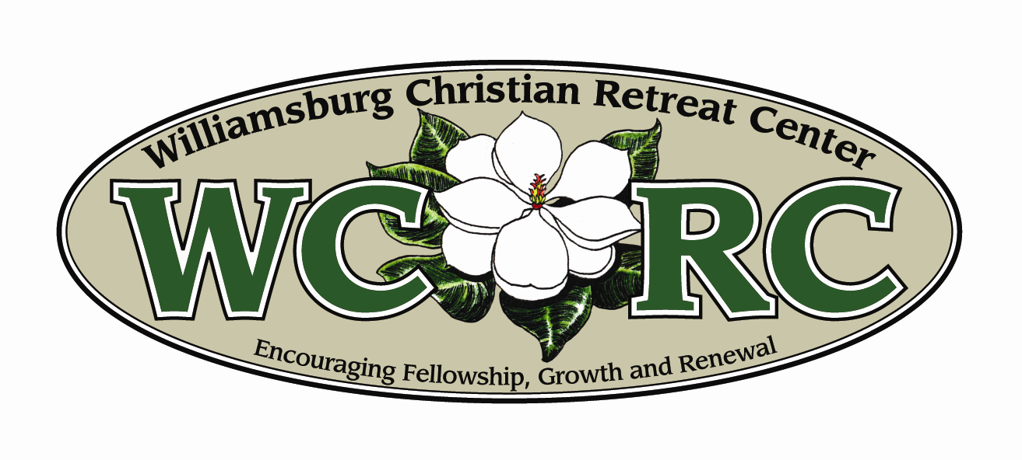

Thanks for your interest in volunteering at WCRC.

In order to get to know you better and to see where you would best fit into our organization, we ask that you fill out a short application. Before you begin your application, we would like to share how WCRC was started over 25 years ago, and how God is currently using WCRC to introduce people to Jesus Christ and provide a place for Christian growth.

In the early 1980’s, a group of people from the Mennonite churches in the Tidewater area came together with the goal of creating a place where young people could go to learn about faith in Jesus Christ, be encouraged to accept Christ as their personal Savior, and grow in their relationship with God. Through much prayer, planning, and giving on the part of many people, Williamsburg Christian Retreat Center was born.

Knowing that many church camps struggle to survive financially in the non-summer months, the founders decided to build facilities that church groups of all ages could utilize year-round. Today we have 8 lodging buildings suitable for adults, families and youth, a dining room that can serve up to 100 guests, an RV campground, 300 acres of land, and lots of options for outdoor recreation.

WCRC is a place where thousands of men, women, children and families, from hundreds of churches of various denominations, come each year to re-connect with each other and focus on the Lord.

Our Mission:

WCRC provides a place for the Holy Spirit to work in the lives of kids and adults through camping and retreats.

Our Core Values:
- Remain faithful to Christ, the Word of God, and the demonstration of His love

- Provide a peaceful setting that encourages a relaxed pace, enjoyment of the outdoors, and worship of God – our Creator, Redeemer and Sustainer

- Present attitudes that are friendly, compassionate, courteous and helpful

- Provide opportunities for adventure, recreation, and fun that will build positive memories for all ages

- Maintain clean and attractive grounds and facilities

Now it is your turn. Please take a moment to fill out the application. Through your sincere responses, we hope to determine if WCRC is a place where the gifts and abilities God has given you match our volunteer needs.

Sincerely,

Bob Briscoe
Executive Director
9275 Barnes Road, Toano, Virginia 23168
Phone: (757) 566-2256 Fax: (757) 566-4875 Email: wcrc@wcrc.info Web: www.wcrc.info

9275 Barnes Road, Toano, Virginia 23168
Phone: (757) 566-2256 Fax: (757) 566-4875 Email: wcrc@wcrc.info Web: www.wcrc.info
Phone: 757-566-2256 • Fax: 757-566-4875 • Email: wcrc@wcrc.info
Web: www.wcrc.info
9275 Barnes Rd. • Toano, VA 23168

Volunteer Application

Applicant Information (Please Print)

Name:__________________________________________________________Date:______________________
(First) (Middle) (Last)

Address:__________________________________________________________________________________

City/State/Zip:___________________________________________Home Phone:________________________

Email Address:______________________________Alternate Phone:__________________________________

Date of Birth (if under 18)________________If minor, please list below the name of your ⁪Father ⁪Mother ⁪Guardian

Name:_______________________________________Telephone:____________________________________

How did you hear about WCRC?_______________________________________________________________

Person to notify in case of emergency

Emergency Contact Person:___________________________________________________________________

Relationship___________________________Telephone_(H)_____________(W)____________(c)__________

Areas of Interest Put the numbers 1,2,and 3 beside your top three choices.

___ Kitchen ___ Housekeeping/Laundry ___ Office
___ Maintenance ___ Grounds & Landscaping ___ Pool
___ Ropes Course* ___ Summer Camp* ___General Assistance
___Weekend Host ___ Camp Nurse* ___Board Member

*Any position that requires working in close proximity to children will require a background check.

Do you have any allergies, physical limitations or medical conditions we should be aware of? Explain:___________________________________________________________________________________
_____________________________________________________________________________

Availability
Put an “x” in the box(s) to indicate when you generally ARE available to volunteer:
Morning
Afternoon
Evening
Sunday Monday Tuesday Wednesday Thursday Friday Saturday

Other availability considerations for WCRC to be aware of: ________________________________________
_____________________________________________________________________________
Statement of Faith

WCRC is a church affiliated ministry whose mission is to provide a place for Christian fellowship, growth and renewal. As such, we desire to employ volunteers and staff whose behavior, lifestyle and faith commitments are in alignment with our expressed Christian mission. Our Statement of Faith is below:

- We believe in one holy and loving God who is Father, Son, and Holy Spirit eternally. God has created all things visible and invisible, has brought salvation and new life to humanity through Jesus Christ, and continues to sustain the church and all things until the end of the age.
- We believe in Jesus Christ, the Word of God become flesh. He is the Savior of the world, who has delivered us from the dominion of sin and reconciled us to God by his death on a cross and calls us to follow him.
- We believe in the Holy Spirit, the eternal Spirit of God, who dwelled in Jesus Christ, who empowers the church, who is the source of our life in Christ, and who is poured out on those who believe as the guarantee of redemption.
- We believe all Scripture (Bible) is inspired by God through the Holy Spirit.
- We believe that God has created human beings in the divine image. We confess that, beginning with Adam and Eve, humanity has disobeyed God, given way to the tempter, and chosen to sin. Through Jesus Christ, God offers salvation from sin and a new way of life. We receive God’s salvation when we repent and accept Jesus Christ as Savior and Lord. Believers are baptized into Christ with water as a sign of their cleansing from sin.
- We believe that peace is the will of God. Led by the Holy Spirit, we follow Christ in the way of peace, doing justice and bringing reconciliation. We place our hope in the reign of God and its fulfillment in the day when Christ will come again in glory to judge the living and the dead.

Are you a Christian who affirms the faith statement above? ___Yes ___No ____Need to clarify (write below)

Church you attend: ______________________________________ Location____________________________

Pastor’s Name______________________________________________Phone___________________________

Other
Answer the questions below. Use an additional sheet of paper if necessary.

Why do you want to volunteer at WCRC?

Where do you see your skills best being used here?

References
Please list the name and phone number of 3 non-family personal references whom we may contact:

Name ________________________________________Phone _____________________________________
Relationship______________________________________________________________________________
How long have you known this person__________________________________________________________

Name ________________________________________Phone _____________________________________
Relationship______________________________________________________________________________
How long have you known this person__________________________________________________________

Name ________________________________________Phone _____________________________________
Relationship______________________________________________________________________________
How long have you known this person__________________________________________________________

History

Have you ever been convicted of a criminal offense? (felony or serious misdemeanor) ___Yes ___No
If yes, please state the nature of the crime(s), when and where convicted, and disposition of the case:
________________________________________________________________________________________
____________________________________________________________________________

Have you ever been accused or convicted of physically or sexually abusing a child? ___Yes ___No

Are there any circumstances involving your lifestyle or background that would call into question your ability to work around children or youth? ___Yes ___No

If yes, please explain:________________________________________________________________________

Release

Please read carefully, and sign below:

I hereby certify that the facts set forth in the above volunteer application are true and complete to the best of my knowledge. I hereby authorize Williamsburg Christian Retreat Center to contact the references listed herein and any secondary references to verify all information provided and to obtain any and all information related to my character. I further hereby release all references from any liability for information provided in good faith.

I understand that any physical activity involves a risk of injury. I also understand that my participation in this program at the Williamsburg Christian Retreat Center is entirely voluntary.
I acknowledge that primary insurance covering any accidents that might occur during my participation in the volunteer program is my responsibility.

I release Williamsburg Christian Retreat Center, its’ owners, employees and staff, from any claims or liability arising out of my participation in this volunteer program.

I give permission for photographs or video that include myself (my son, or daughter) to be used in publicity.

Signature _________________________________________________ Date ____ / _____ / _____
*If the participant is under age 18, the above signature must be a parent or legal guardian.

The Next Step

Return your completed application to WCRC. Someone will contact you soon.

Williamsburg Christian Retreat Center
9275 Barnes Rd.
Toano, VA 23168

Thanks for your interest in Williamsburg Christian Retreat Center!

